Ideation Phase
Define the Problem Statements
Date | 02 February 2026
Team ID | LTVIP2026TMIDS88090
Project Name | AUTOSAGE APP USING GEMINI FLASH
Maximum Marks | 2 Marks

Customer Problem Statement Template:
The current vehicle research and decision-making process presents significant challenges for customers, impacting their confidence and overall satisfaction. Buyers, particularly those evaluating vehicles in the Indian market, often struggle with fragmented information, inconsistent specifications, unclear pricing structures, and limited personalized guidance. Additionally, comparing ICE and EV options requires technical understanding that many users do not possess. These hurdles lead to confusion, decision fatigue, and a less-than-optimal purchase journey, potentially affecting trust in available digital resources.
To enhance user experience and improve decision clarity, there is a need for a centralized, intelligent, and structured vehicle advisory system. By leveraging AI-powered analysis through Gemini Flash, the AutoSage application aims to address these pain points. Through structured intelligence reports, contextual recommendations, and multimodal analysis (text + image), the platform can deliver accurate, market-relevant insights. This approach ensures a streamlined, user-friendly experience that aligns with modern customer expectations and fosters trust, clarity, and informed decision-making.
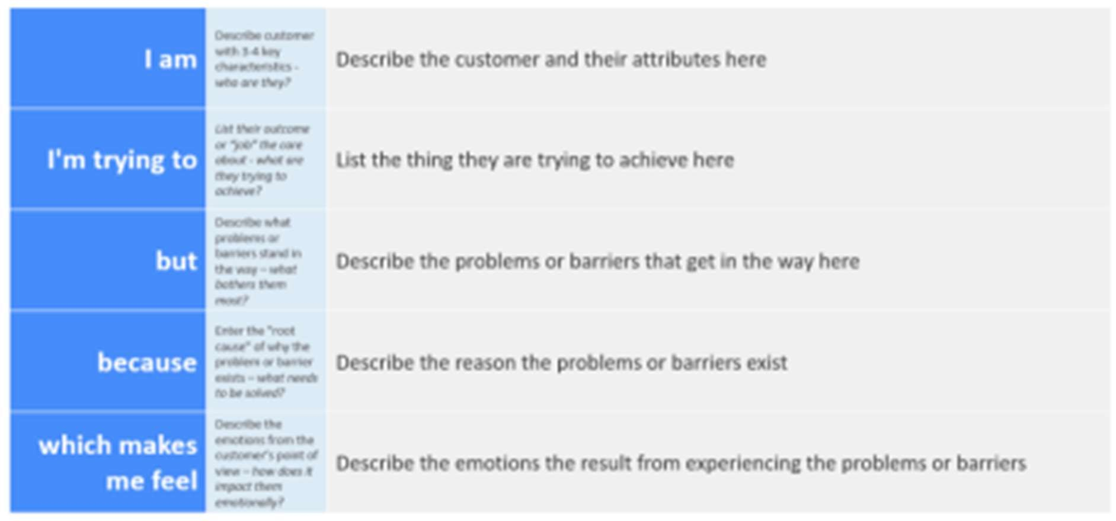
Reference: https://miro.com/templates/customer-problem-statement/ Example:

Problem Statement (PS) | I am (Customer) | I’m trying to | But | Because | Which makes me feel
PS-1 | A vehicle buyer in India researching options online. | A vehicle buyer in India researching options online. | Compare  cars/bikes and choose the best vehicle based on budget, performa nce, and long-term ownershi p value. | Information is scattered across websites, specification s are inconsistent, pricing varies by source, and EV vs ICE comparisons are confusing. | Most platforms provide either generic reviews or raw technical data without structured analysis or personalized guidance.
PS-2 | A vehicle owner or buyer who has only a vehicle image (photo from street/show room/social media). | Identify the exact model, variant, and key specifications to understand its value and market positioning. | I cannot accuratel y  determin e the variant, engine type (ICE vs EV), pricing, or feature difference s just  from the image. | I cannot accurately determine the variant, engine type (ICE vs EV), pricing, or feature differences just from the image. | Confused and unsure about the vehicle’s authenticity, specifications, and buying relevance.

